

ALLIANCE GIRLS 2025 PREDICTION
POSSIBLE KCSE EXAM
451/2
COMPUTER STUDIES
PAPER 2
TIME: 2½ HOURS

NAME……………………………………………………………………………………….
SCHOOL……………………………………………… SIGN………………………..
INDEX NO……………………………………………. ADM NO……………………

Kenya Certificate of Secondary Education.

Instructions to candidates
- Write your name and Index number at the right hand corner of each print out.
- Write your name and Index number on the CD provided.
- Write the name and version of the software used for each question attempted in the answer sheet
- Answer all the questions
- Passwords should not be used while saving in the CD provided.
- All answers must be saved in your CD provided.
- Arrange your printouts and staple them together
- Hand in all the printouts and the CD used

QUESTION 1
- Use DTP software to design the following business card using the following layout specifications:
  - Paper size A4 portrait. (2 marks)
  - Set the margins to 0.5 inches all round. (2 marks)
  - Divide the page into TWO columns (2 marks)
  - The border should occupy the first column (2 marks)
- Prepare the publication as exactly as it appears and save it as Business card. (10 marks)

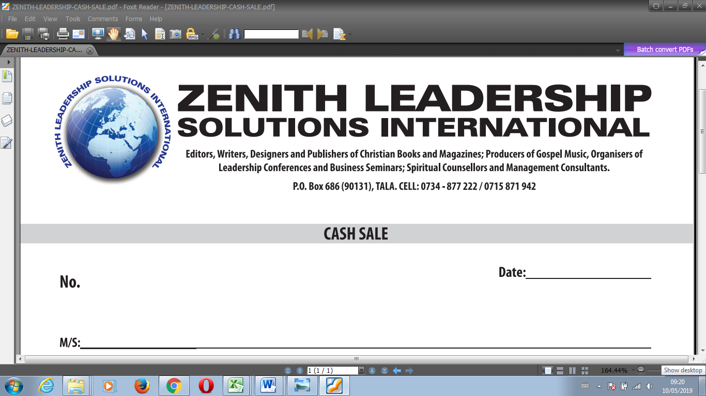
Service Beyond The Ordinary
- Insert your full name above the heading “ZENITH LEADERSHIP…” and centre it across(5 marks)
- Create the logo to occupy between 0.8” to 1.80” left and 0.70” to 1.85” from top. (5 marks)
- The title should occupy between 1.70” to 7.50” across and 0.75” to 1.45” from top. Font Arial black with italics and fill effect pattern of dark horizontal. (5 marks)
- The words “ZENITH LEADERSHIP” should occupy 2.50” to 5.70” across and 1.50” to 2.00” from top. Font Book antique size 26, bold and centered. (4 marks)
- The rest of the text is in font Bodoni MT size 12. (2 marks)
  - Align all the text as shown. (2 marks)
  - Group the publication as one. (2 marks)
  - Fit FOUR copies of the design into a single page. (2 marks)
- Include a page header with your index number. (2 marks)
- Save as Updated Business card. (1 mark)
- Print the publication Business card and Updated Business Card. (2 marks)

Question 2
The table below shows records extracted from Motors Sales Company Database. Create a database and name it MOTOR SALES. (1 mark)
Customer  Name | Customer  Address | Customer  Town | Car  Reg No | Car  Type | Car  Make | Car  price | Customer  ID | Amount  paid
Ogutu | 254 | Nakuru | KBJ 001T | Truck | Nissan | 1,100,000 | B001 | 800,000
John | 678 | Eldoret | KCM 002M | Bus | Mazda | 2,400,000 | B002 | 2,000,000
Uhuru | 963 | Nairobi | KBB 003V | Saloon | Toyota | 800,000 | B003 | 800,000
Ogutu | 147 | Nakuru | KCJ 004B | Pick up | Peugeot | 1,000,000 | B004 | 700,000
Chumba | 456 | Bungoma | KCH 678B | Lorry | Isuzu | 3,000,000 | B005 | 2,000,000
Kariuki | 789 | Webuye | KBB 006N | Pick up | Toyota | 1,800,000 | B006 | 1,600,000
John | 678 | Eldoret | KBJ 007D | Bus | Scania | 7,500,000 | B002 | 7,500,000
Uhuru | 963 | Nairobi | KCC 678G | Truck | Toyota | 1,800,000 | B003 | 1,800,000
Phillip | 159 | Kisumu | KCJ 009H | Saloon | Nissan | 9,00,000 | B007 | 900,000
Ogutu | 254 | Nakuru | KCH 010L | Pick up | Isuzu | 1,500,000 | B001 | 1,200,000
Uhuru | 357 | Kisumu | KCJ 011J | Saloon | Peugeot | 600,000 | B008 | 600,000
Kariuki | 789 | Webuye | KBG 012B | Bus | Isuzu | 10,000,000 | B006 | 9,500,000
Ogutu | 147 | Nakuru | KDA 013A | Truck | Nissan | 2,700,000 | B004 | 2,700,000

- Using the data above, create a table that will hold Car details and another table to hold Customer details. Name them TABLECAR and TABLECUSTOMER respectively and set appropriate primary keys.
(4 marks)
- Enforce referential integrity between two tables. (2 marks)
- Create different input forms for each table. Name them FORMCAR and FORMCUSTOMER. Use them to enter data into the tables. (12marks)
- Display a report only showing the details of the Customers who have cleared paying for the Car. Name the report REPORTCLEARED. Add “CLEARED CUSTOMERS’’ as the title of the report. (7 marks)
- Using the two tables create an outlined report showing the customer details, the total amount paid by each customer and the total amount received by the company. Name the report SUMMARY and the title as “OVERALL CUSTOMERS REPORT.’’ (8 marks)
- Create a query to display the Car details with balances of less than 300,000. Name the query as BALQUERY. (4marks)
- Create a report showing the Car type, the total sales for each car type and the grand total. Name the report as REPORTGRAND. (6 marks)
- Using landscape orientation, print REPORTCLEARED, SUMMARY and REPORTGRAND with footers bearing your lastname and index number at the center of the page. (6 marks)

